Assessment 21 Sree vidya 28-12-23

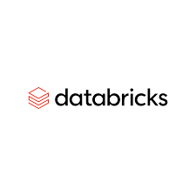

Azure data bricks for data engineering

Azure Databricks is a cloud-based big data and analytics platform provided by Microsoft Azure. It is built on top of Apache Spark, a powerful open-source distributed computing system. Azure Databricks is designed to simplify big data processing and analytics by providing a collaborative environment for data engineers, data scientists, and other stakeholders.

Here, I'll provide you with some basic concepts and examples for data engineers using Azure Databricks:

**1. Workspace:**

The Azure Databricks workspace is a collaborative environment where you can create and manage notebooks, clusters, libraries, and dashboards.

It provides a collaborative space for teams to work on data-related projects.

**2. Notebooks:**

Notebooks are interactive documents that can contain both code (in multiple languages like Python, Scala, SQL, etc.) and rich-text elements.

Data engineers can use notebooks to write and execute code for tasks such as data extraction, transformation, and loading (ETL).

**3. Clusters:**

Clusters are groups of virtual machines that run Spark jobs.

Data engineers can create clusters with the necessary configuration and resources for their data processing tasks.

Example:

Create a cluster with specific configurations in the Azure Databricks workspace.

**4. Libraries:**

Libraries are external packages or dependencies that can be added to a cluster.

Data engineers can use libraries to extend the functionality of their Spark jobs.

Example:

Install and use a third-party library for data processing in a notebook.

**5. Jobs:**

Jobs allow you to schedule and automate the execution of notebooks or JAR files on a cluster.

Data engineers can schedule ETL jobs to run at specific intervals.

Example:

Schedule a job to run a notebook that performs daily data processing tasks.

6**. Data Storage:**

Azure Databricks can interact with various data storage solutions, such as Azure Data Lake Storage, Azure Blob Storage, etc.

Data engineers can read and write data to these storage systems.

Example:

Read data from Azure Data Lake Storage into a Spark DataFrame.

**7. Integration with Azure Services**:

Azure Databricks integrates with other Azure services like Azure SQL Database, Azure Synapse Analytics, etc.

Data engineers can leverage these integrations for seamless data movement and analysis.

Example:

Move data from Azure Blob Storage to Azure SQL Database using Azure Databricks.

*APACHE SPARK:*

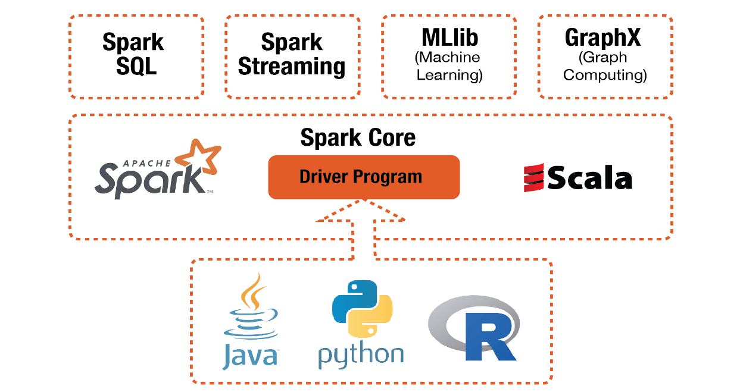

Apache Spark is a lightning-fast unified analytics engine for big data processing and machine learning, Apache Spark is an open-source, distributed computing system that provides a fast and general-purpose cluster-computing framework for big data processing. It was developed to address the limitations of MapReduce, offering in-memory processing, ease of use, and support for various data processing tasks. Here are the key features of Apache Spark:

**1. Speed:**

In-Memory Processing: Spark processes data in-memory, reducing the need to write to and read from disk, which significantly speeds up data processing compared to traditional disk-based systems.

**2. Ease of Use:**

Unified API: Spark provides a unified API for distributed data processing in multiple languages, including Scala, Java, Python, and R. This simplifies the development process and allows users to choose the language they are most comfortable with.

**3. Versatility:**

Batch and Stream Processing: Spark supports both batch processing (processing large datasets at once) and stream processing (processing data in real-time or near real-time using Spark Streaming).

4**. Advanced Analytics:**

Machine Learning Library (MLlib): Spark includes a scalable machine learning library with various algorithms for classification, regression, clustering, and collaborative filtering.

**5. Interactive Querying:**

Spark SQL: Allows users to query structured data using SQL in a Spark application, providing a familiar interface for data analysts.

SQL:

-- Example Spark SQL query SELECT name, age FROM people WHERE age BETWEEN 20 AND 30

**6. Graph Processing:**

Graph X: Spark includes a graph processing library for analysing graph-structured data.

scala

// Example Graph X code Val graph = GraphLoader.edgeListFile(Sc, "path/to/edges.txt") Val ranks = graph. PageRank (0.0001). vertices

**7. Fault Tolerance:**

Resilient Distributed Datasets (RDDs): Spark's fundamental data structure is RDD, which is fault-tolerant. If a node fails during processing, Spark can recover lost data using lineage information.

**8. Scalability:**

Cluster Computing: Spark is designed for distributed computing, making it highly scalable. It can efficiently scale from a single machine to large clusters.

**9. Integration with Hadoop:**

Hadoop Compatibility: Spark can run on Hadoop Distributed File System (HDFS) and can read existing Hadoop data.

scala

// Example Spark code reading data from HDFS val textFile = sc.textFile("hdfs://...")

**10. Community and Ecosystem:**

Active Community: Spark has a vibrant and active open-source community, contributing to its development and providing support.

**Ecosystem**: Spark has a rich ecosystem with additional libraries and tools, including Spark Streaming for real-time data processing, SparkR for R language support, and more.

Apache Spark's combination of speed, ease of use, versatility, and scalability makes it a popular choice for organizations dealing with large-scale data processing and analytics. It has become a foundational technology in the big data ecosystem.

***Azure Databricks:***

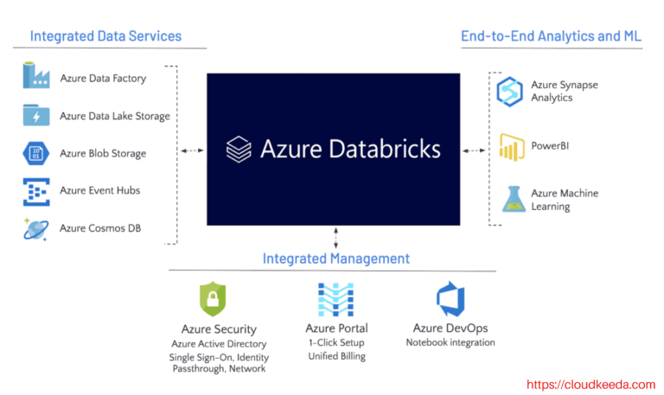

Azure Databricks is a cloud-based big data and analytics platform provided by Microsoft Azure. It is built on top of Apache Spark, a powerful open-source distributed computing system. Azure Databricks is designed to simplify big data processing and analytics by providing a collaborative environment for data engineers, data scientists, and other stakeholders. Here are some key features and components of Azure Databricks:

**Key Features:**

1. **Unified Analytics Platform:**

* Provides a unified platform for data engineering, data science, and business analytics.
* Enables collaboration between different roles within an organization.

1. **Apache Spark Integration:**

Azure Databricks is built on top of Apache Spark, allowing users to leverage Spark's capabilities for distributed data processing and analytics.

1. **Collaborative Workspace:**

Offers a collaborative environment with notebooks where users can write and execute code in languages such as Python, Scala, SQL, and R.

1. **Managed Clusters:**

* Allows users to create and manage clusters with the required configuration for processing large-scale data workloads.
* Clusters are automatically scaled based on workload demands.

1. **Libraries and Dependencies:**

* Supports the use of libraries to extend the functionality of Spark.
* Users can install and manage libraries for Python, Scala, and R.

1. **Integration with Azure Services:**

Seamlessly integrates with various Azure services, including Azure Blob Storage, Azure Data Lake Storage, Azure SQL Database, and Azure Synapse Analytics.

1. **Security and Identity Management:**

* Provides integration with Azure Active Directory for identity management and access control.
* Supports Azure RBAC (Role-Based Access Control) for fine-grained access permissions.

1. **Jobs and Automation:**

* Enables users to schedule and automate the execution of notebooks or jobs.
* Jobs can be triggered at specific intervals or events.

1. **Data Visualization:**

* Supports visualizations and reporting using popular tools like Matplotlib, Seaborn, and others.
* Integration with Azure Synapse Analytics for advanced reporting.

1. **Machine Learning Integration:**

* Integrates with Azure Machine Learning for building and deploying machine learning models.
* Allows data scientists to seamlessly transition from data exploration to model deployment.

1. **AutoML (Automated Machine Learning):**

* Provides capabilities for automated machine learning, making it easier to build and deploy models.

1. **Cost Management:**

* Offers cost management features to monitor and optimize resource usage.
* Integration with Azure Cost Management for comprehensive cost analysis.

**Use Cases:**

* **Data Transformation and ETL:**

Ideal for processing and transforming large volumes of data using Spark.

Supports ETL (Extract, Transform, Load) operations on diverse data sources.

* **Data Exploration and Analysis:**

Provides a collaborative environment for data scientists and analysts to explore and analyze data.

* **Advanced Analytics and Machine Learning:**

Integrates with Azure Machine Learning for building and deploying machine learning models.

Enables advanced analytics on large datasets.

* **Real-time Analytics:**

Supports real-time processing and analytics using Spark Streaming.

Azure Databricks simplifies the process of setting up and managing Spark clusters, making it easier for organizations to harness the power of big data for their analytics and machine learning needs.